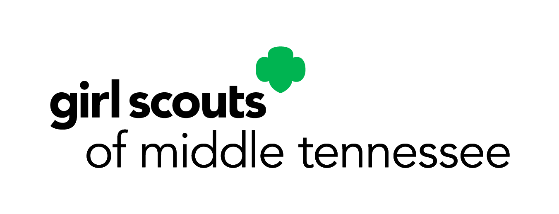

2025 Girl Scout Cookie Program Changes
Frequently Asked Questions
Beginning in the 2025 cookie season, Girl Scouts of Middle Tennessee troops now can earn up to 90 cents per package, a 40% increase over the current amount. During this next program year, the cookie costs will increase as follows: Thin Mints®, Samoas®, Tagalongs®, Trefoils®, Do-Si-Dos® and Lemon-Ups™, Adventurefuls will be $5.00 per package; while Toffee Tastic® and S’Mores™ will be $6.00 per package.
When will the price increase take effect?
The price increase will go into effect for the 2025 cookie program, which is currently scheduled to begin on December 16, 2024.
What are the cookie prices for the 2024-2025 cookie program?
For the upcoming cookie program beginning in December 2024, the cost will be $5.00 per package for Thin Mints®, Samoas®, Tagalongs®, Trefoils®, Do-Si-Dos®, and Lemon-Ups™, Adventurefuls. The cost for Toffee Tastic® and S’Mores™ will be $6.00 per package.
How long has it been since GSMIDTN changed the cookie price?
In two decades, the council has only raised the prices twice. Once in 2003, and again in 2021.
Why is GSMIDTN announcing this price increase now?
Girl Scouts of Middle Tennessee values the dedication and work of our volunteers. Our goal is to deliver news of significant change with adequate notice so that volunteers are well informed. By providing this lead time, GSMIDTN hopes to empower our volunteers with information, tools and knowledge that can set them up for success each cookie season.
Will GSMIDTN participate in Digital Cookie?
GSMT will continue to provide an online method of selling cookies.
Why is GSMIDTN raising the price per package of cookies?
The cost per package from the bakery will increase by a minimum of 17% next year, if commodity prices continue to escalate the price could go up by as much as 30%. Rewards have also seen a significant Increase going up as much as 10% yearly.
Will the troops receive an increase in proceeds?
Girl Scouts of Middle Tennessee, partnering with the Cookie Committee, have agreed to an increase in troop proceeds based on a tiered level, ranging from $.65 to $.90 per package based on goal setting achievement level, a 40% increase over the current amount. Tiers will also depend on participation with Fall Product, Troop Cookie Selling PGA levels and an increase in base cookie proceeds.
Is GSMIDTN still the lowest in the country?
Each Girl Scout council sets the price per package for cookies sold within their jurisdiction. Based on the data available, Girl Scouts of Middle Tennessee remains one of the lowest priced in the Southeastern region of the country.
Who makes the decision for an increase in pricing?
Girl Scouts of Middle Tennessee appointed a Cookie Committee comprised of volunteers from areas we serve. The committee reviewed cookie data and made a recommendation to the GSMIDTN Board of Directors. The GSMIDTN Board reviewed the information provided by the cookie committee and approved the recommended troop incentives and price increase.
Who are the Individuals on the Cookie Committee that make these decisions?
The Cookie Committee are peers among the 39 counties that include troop leaders, SU Cookie Coordinators, SU managers, Girl Scout Parents, and Girl Scout Board Members. The two staff members that sit on the Committee are only present for information support that the Committee may need.
What happens to the membership fees?
All of the membership fees that are paid go directly to GSUSA at the New York office for the National Membership fee for your Girl and/or Adult membership. When the Girl Scouts of Middle Tennessee council subsidizes any part of the membership fees then those fees are paid by council to make up that difference to cover the required fee.
What is a “council fee” that other councils charge?
Some councils charge an additional “council fee” to offset membership fees that stay local within that council. Girl Scout of Middle Tennessee does not charge any additional fees for membership to our parents and/or volunteers.

