Embracing Autism Patch Requirements:
Daisy: Complete the “required” section
Brownies & Junior: Complete the “required” section and one optional activity
Cadette: Complete the “required” section and two optional activities
Senior & Ambassador: Complete the “required” section and three optional activities

Required:
- Read and discuss the “What is Autism” slideshow:
- (copy and paste link into search bar)
- https://www.canva.com/design/DAFhcH97HOA/Qo2Ddss7jz27ynfSBAgDVA/view?utm_content=DAFhcH97HOA&utm_campaign=designshare&utm_medium=link&utm_source=publishsharelink
- Research people with autism and their story. Here are a few links to get you started!
- Real Stories | Autism | NCBDDD | CDC
- https://www.autism.org.uk/advice-and-guidance/stories
- Research symptoms of autism and which ones are more/ less common. Here are a few links to get you started!
- https://www.cdc.gov/ncbddd/autism/signs.html
- https://www.autismspeaks.org/what-are-symptoms-autism
- Create a poster or a slideshow over what you learned and why autism awareness is important and present it to the rest of your troop.
- Be kind to people no matter the challenges they face!

Optional:
- Spend some time volunteering with people with autism at your school or find other volunteer options here:
- https://autismtn.org/Volunteer
- Interview a clinical coordinator of an autism program.
- Raise awareness in your community by sharing what you’ve learned to your friends, family, or school.
- Make autism awareness posters and hang them up at your school.
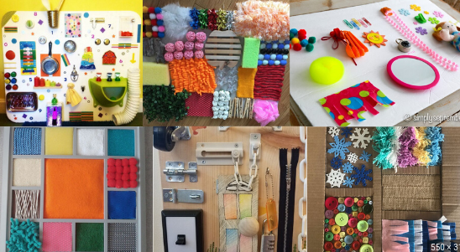
- Create a sensory device, board, or book to donate to an autism program near you. Examples:
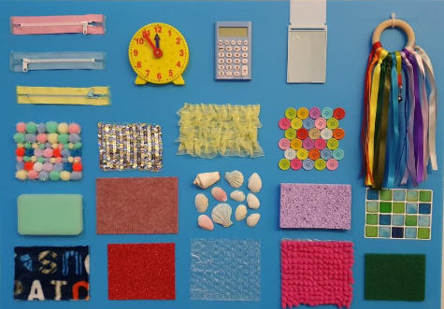

When you’ve completed the patch, bring this sheet filled out to The Cabin to purchase your Embracing Autism patches!
Troop Number: ______________
Number of Girls Completing Patch: ______________
Troop Leader Name: _______________________________________
Contact Phone Number: ____________________________________
Contact E-mail: ___________________________________________

This Council’s Own Patch was created by Leah Rose as part of my Silver Award Project, July 2023

