**Crosswind Quarter Zip Tie-Dye Sweatshirt**

**Pre-orders**

60% cotton / 40% polyester – Unisex **Price $45+tax.**

**Girl Scouts of Middle Tennessee will be on the left chest.**

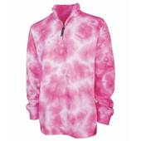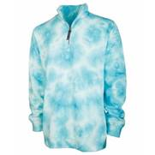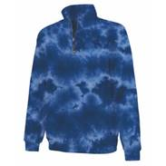

Pink Aqua Navy

Name_______________________________________________

Address_____________________________________________

City______________________________________ State _______ Zip ______________

Ph: _______________________________ Email- _____________________________________________

**\*\*Must have at least 50 ordered. Once we reach 50, we will contact you for payment\*\***

|  |  |  |  |  |  |  |  |
| --- | --- | --- | --- | --- | --- | --- | --- |
| **Quantity Ordered** | **Color** | **Size** | **Price** |  |  |  |  |
|  |  |  |  |  |  |  |  |
|  |  |  |  |  |  |  |  |
|  |  |  |  |  |  |  |  |
|  |  |  |  |  |  |  |  |
|  |  |  |  |  |  |  |  |
|  |  |  |  |  |  |  |  |